Dear Parents,
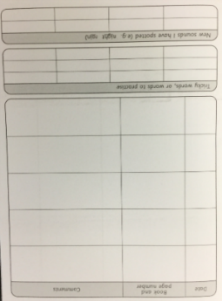
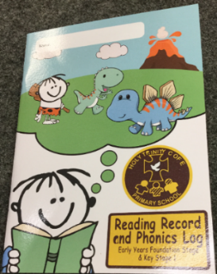
I have done this letter to inform you on how to fill out your child’s reading record and to give you some information about homework.

Reading Books and Reading Records
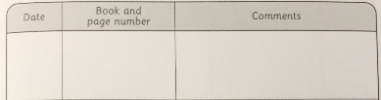
When reading with your child we ask parents to make a comment and/or sign their child’s reading record. Each week the Nursery staff will complete the boxes with the title of the books we are sending home (see below). We will give out homework and a reading book every Thursday and expect you to bring in your child’s homework and book bag every Tuesday. Parents can add a signature by the Nursery staffs comment or add their own comment when they have shared a book with their child. We are not expecting your child to be reading words or sentences. We just want parents to read and share a book with their child to help develop their language, reading and comprehension skills.
14/09/20
The Gruffalo
Please read and share this book with your child. Miss Ince.

Signing Reading Records and Prizes
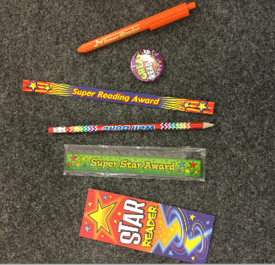
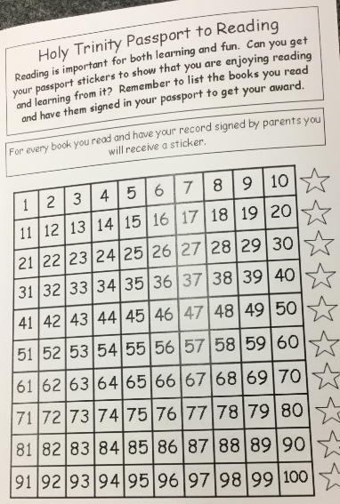
Your child can earn prizes for every 10 books they read but these must be different books. For every book your child reads that is signed by an adult/parent, a member of staff will cross off a number on the passport (see below). We will not cross off the passport for the same book read 10 times. (E.g. if your child reads ‘The Gruffalo’ 10 times, we will only sign the passport once). Any book can be read, including books from home so if you read a book from home to your child at bedtime, add it to your child’s reading diary but don’t forget to sign it!!
Homework Books
Homework books are for homework only and should not be scribbled in or used to do any other drawings by anyone else. If your child wants to do extra work, please feel free to do this on a separate piece of paper and bring it in as additional work.

Busy Things
Busy things is an educational app used at school that links to the areas of learning of the EYFS curriculum. In your child’s book bag we have given you a username and password so that your child can access busy things at home.

